|  |  |  |
| --- | --- | --- |
|  | **INDEX** |  |
|  |  |  |
| **SL.NO** | **CONTENTS** | **PAGE NO** |
| 01. | Introduction | 02. |
| 02. | Introduction to Html, CSS and Java Script | 02. |
| 03. | System Requirements | 03. |
| 04. | Module description | 03. |
| 05. | Screenshots | 4-6 |
| 06. | Conclusion | 07. |
|  |  |  |

**INTRODUCTION**

The main objective of Online Book Store is to create an online book store that allows users to purchase books online. Selected books are displayed in a tabular format and users can order their books online. Using this website, the user can register and get logged in and purchase books online instead of going out to the book store and wasting time. The admin can add books. This Online Book Store is used to overcome the entire problem which we are facing currently, and making manual system to computerized system. It reduces the paperwork. This project is developed using Html, CSS, JavaScript.

**HTML:** The Hyper Text Markup Language is the standard markup language for documents designed to be displayed on the browser. It is used to structure web pages. HTML elements are the building blocks of HTML pages. With HTML constructs, images and other objects such as interactive forms may be embedded into the rendered page. HTML provides a means to create structured documents by denoting structural semantics for text such as headings, paragraphs, lists, links, quotes and other items. HTML elements are delineated by tags, written using angle brackets. Tags such as <img/> and <input/> directly introduce content into the page. Other tags such as <p> surround and provide information about document text and may include other tags as sub-elements. Browsers do not display HTML tags but use them to interpret the content of the page.

**CSS:** Cascading style sheet is used to style an Html document. CSS describes how HTML elements should be displayed. CSS is designed to enable the separation of presentation and content, including layout, colors, and fonts. This separation can improve content accessibility; provide more flexibility and control in the specification of presentation characteristics; enable multiple web pages to share formatting by specifying the relevant CSS in a separate .css file, which reduces complexity and repetition in the structural content; and enables the .css file to be cached to improve the page load speed between the pages that share the file and its formatting.

**JAVASCRIPT:** JavaScriptis a scripting language that enables you to create dynamically update content, control multimedia, animate images, and pretty much everything else. JavaScript helps you create really beautiful and crazy fast websites. We can develop our website with a console like look and feel and give the best Graphical User Experience. JavaScript usage has now extended to mobile app development, desktop app development, and game development. Great thing about JavaScript is that we can find tons of frameworks and Libraries already developed which can be used directly in our software development to reduce your time to market.

**SYSTEM REQUIREMENTS:**

HARDWARE REQUIREMENTS:

* PROCESSOR: 11th Gen Intel(R) Core(TM) i5-1145G7 @ 2.60GHz
* PROCESSOR SPEED: 2.61 GHz
* RAM: 16.0 GB
* MONITOR: Standard Monitor
* KEYBOARD: Standard keyboard
* MOUSE: HP Touchpad

**SOFTWARE REQUIREMENTS:**

* OPERATING SYSTEM: Windows 10 Pro
* FRONT END: Html, CSS, JavaScript

**MODULES OF ONLINE BOOK STORE:**

1. **Home**: The Home page contains the Login Page and About us page in it.
2. **Admin login**: Admin login page helps the admin to get logged in and add the new books. The admin activities are carried out in this module.
3. **Add Books**: The admin can easily add the new books into this module using the book name, price and picture of that book. This reduces the admin’s manual work and saves his time.
4. **User Register/ login**: This module allows the users to register themselves by adding the basic information such as name, email, password, gender and agree to the instructions of the book store and easily get registered. After getting registered the users can get logged in to the website and access the books available and add them to cart and also purchase them.
5. **Books**: The users can explore the variety of books and add the books that they wish to buy.
6. **About us:** This module provides a bit of information about the website and takes us back to the home page.

**SCREENSHOTS:**

1. HOME PAGE:

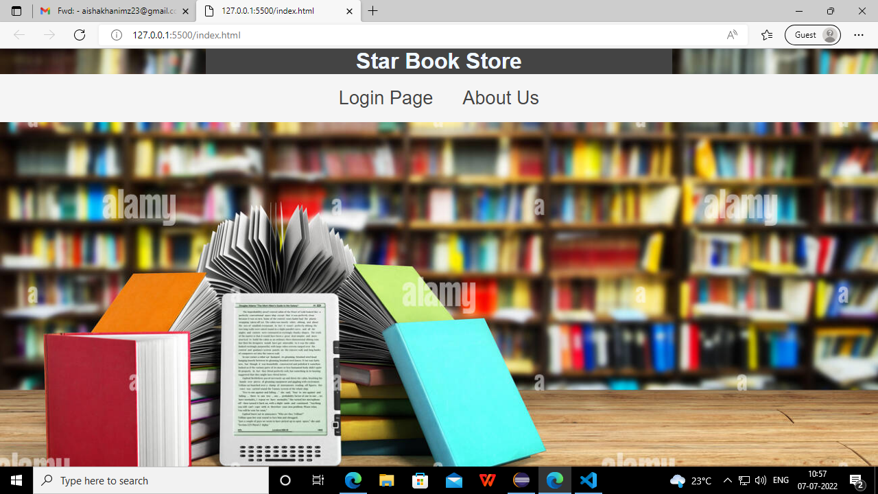

1. LOGIN MAIN PAGE:

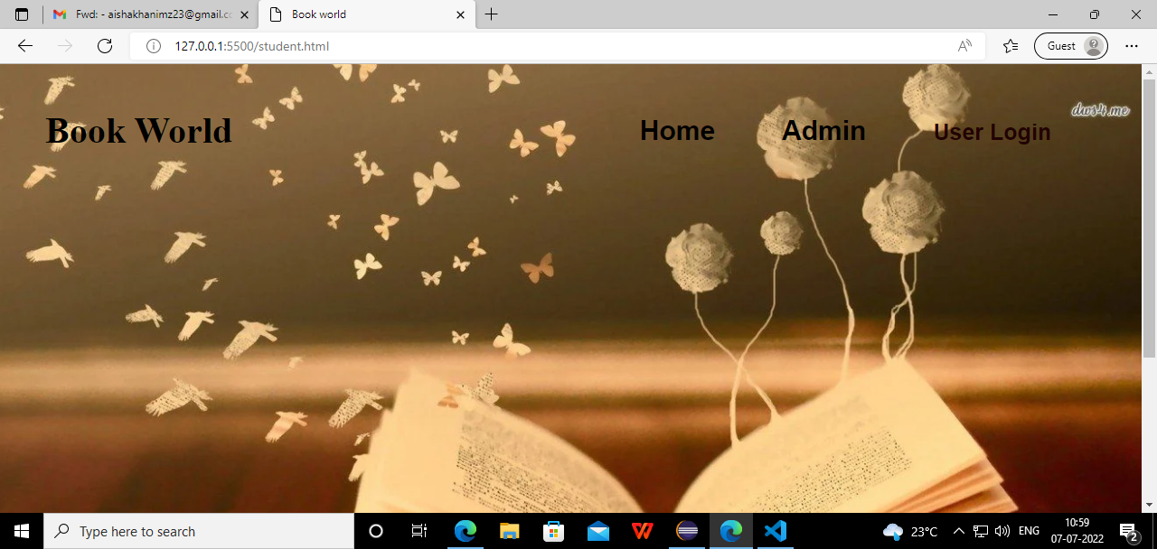

1. ADMIN LOGIN:

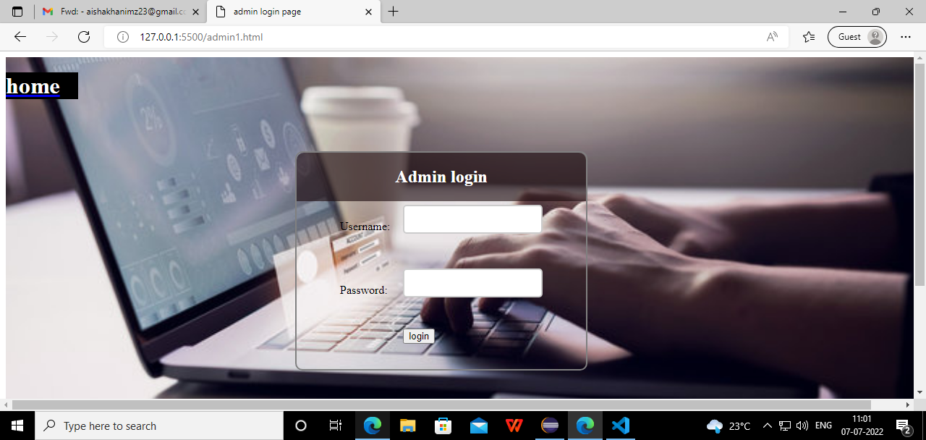

1. ADMIN ADD BOOKS PAGE:

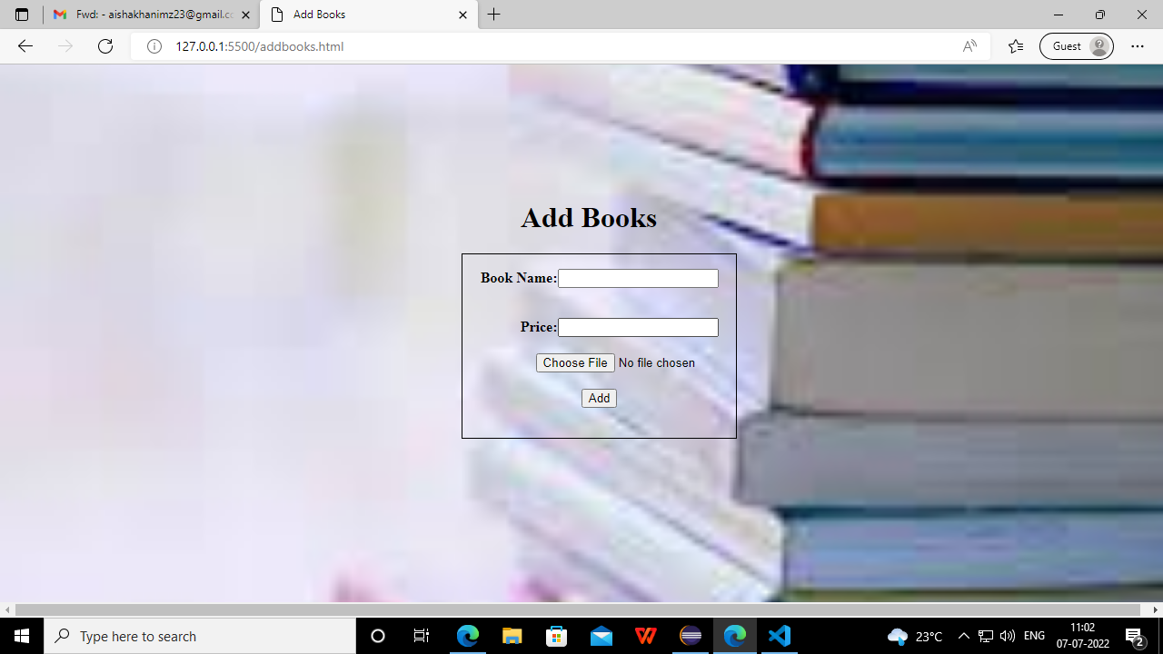

1. USER REGISTER PAGE:

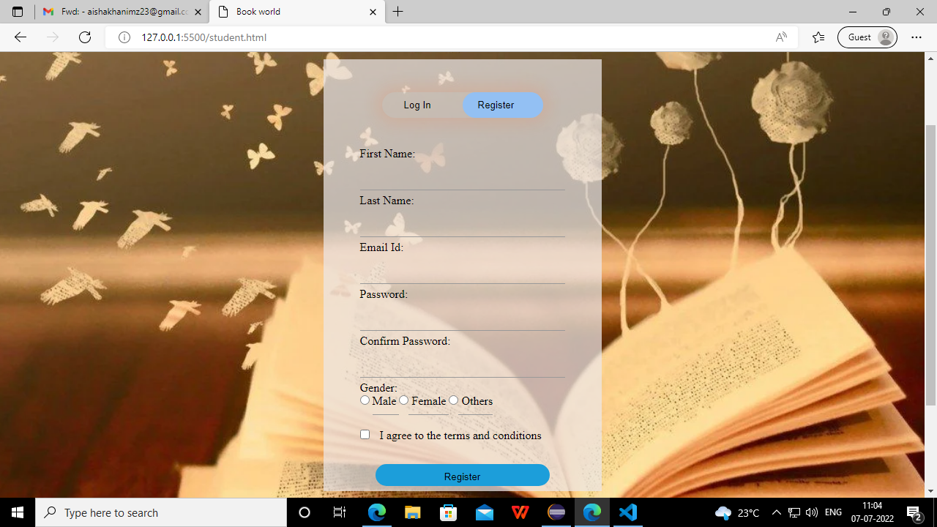

1. USER LOGIN PAGE:

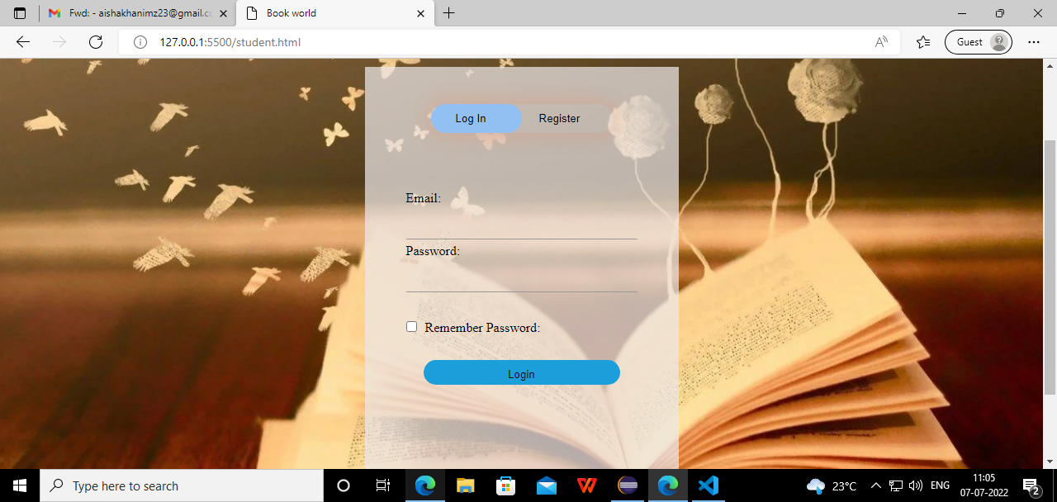

1. BOOKS AND ADD TO CART PAGE:

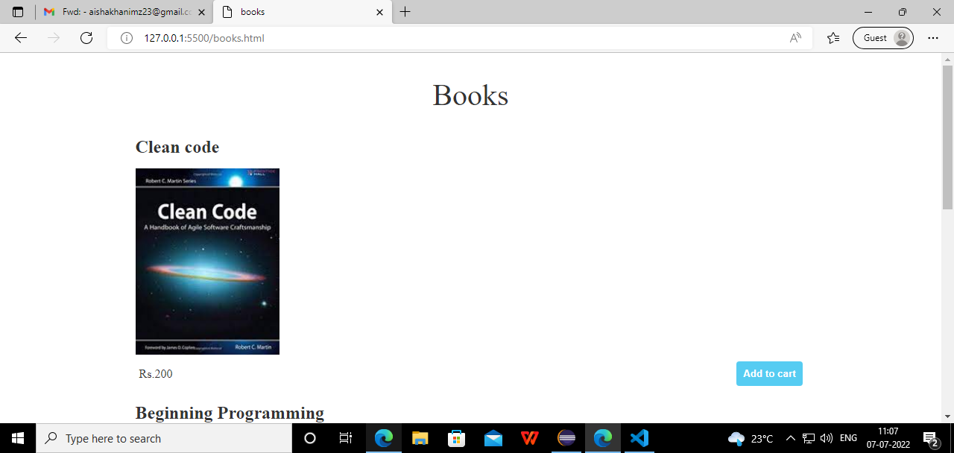

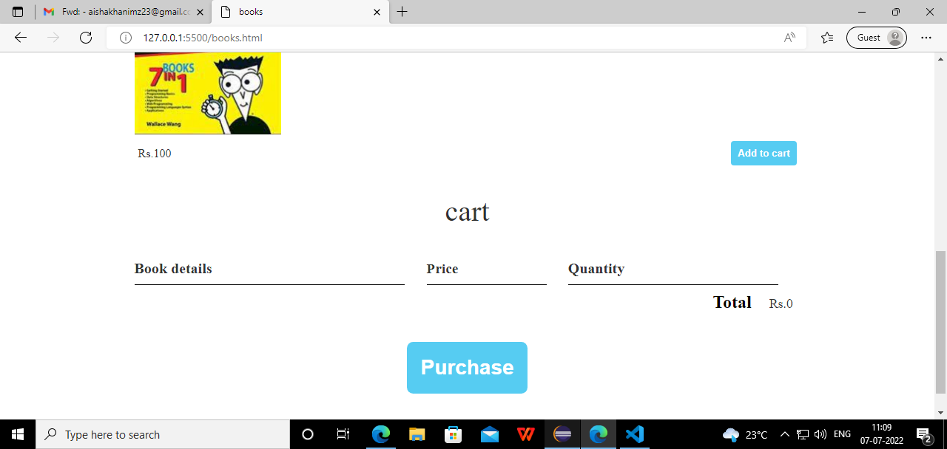

**CONCLUSION:** Research and development are continuous process; this is same in computer development. However, improvement in the efficiency of this new system provides room for further**.** This project reduces the work of the book store and manual work. And also, the users can purchase the books easily at home itself, the users need not go to the store to buy the books. The users can explore many books and purchase them also. The registration process is also as simple as that. The online book store makes the work easy for both admin and users also.